
‘Your Fisheries’ Consultation Questionnaire – River Loddon
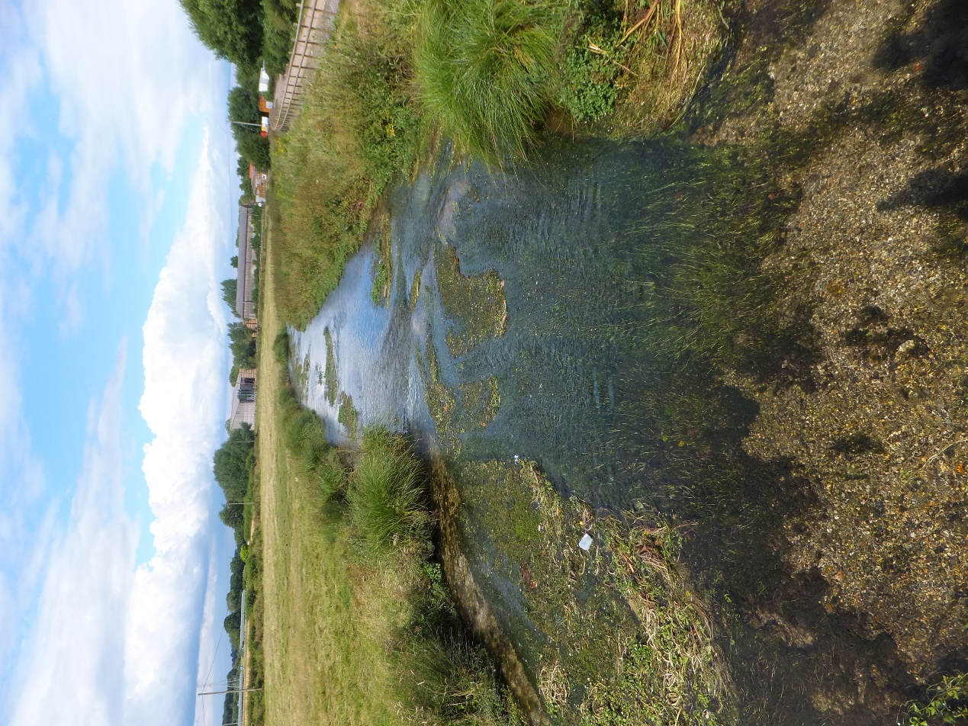
Your river needs your help!

Take part in the questionnaire and have your say…

River Loddon – ‘Your Fisheries’

What is ‘Your Fisheries’?

‘Your Fisheries’ is an initiative developed by The Rivers Trust, the Environment Agency and the Angling Trust. It is a web-based application that brings together evidence and knowledge from a range of different sources to help produce fisheries action plans. These plans are intended to represent a multi-partner perspective on the current status of fish populations and fishing opportunity in the catchment, the key factors affecting them and the actions required to maintain and/or deliver improvements.

It is envisaged the initiative will be implemented in every catchment in due course. Prior to this National coverage, ‘Your Fisheries’ is currently in a pilot phase, with half a dozen pilots being run in catchments throughout the country. The Loddon catchment has been chosen as a pilot catchment, therefore ‘Your Fisheries’ will be trialled in the Loddon to aid learning of how the process could work and refinement of the web-based application.

What’s the Process?

This initial questionnaire forms the first step in the process,. Responses to the questionnaire and an initial gathering of information (fisheries survey data, known issues from Environment Agency investigations etc.) will then be used to build a basic plan in the web-based application, this will then be consulted on again through the Loddon Fisheries and Conservation Consultative (LFCC) and refined.

Who is Running the Pilot in the Loddon?

The South East Rivers Trust (www.southeastriverstrust.org) are looking to produce a plan for the River Loddon catchment and to help us put together this plan we are looking to collect information and gain your views by completing the questionnaire below on the following topics in the River Loddon Catchment.

- The current status of fish populations
- Key factors affecting fish populations
- Specific issues with the potential to impact fish population
- Actions to maintain or improve fish populations
- Monitoring
- Fishing Opportunity and fishing access

Please note all views and information gathered will be treated with confidentiality. For further details please contact Chris Gardner at chris@southeastriverstrust.org

About You

Name:

Address:

E-mail:

Member of angling club or other organisation:

Are you happy to receive further information related to ‘Your Fisheries’ via the e-mail address provided: Yes No

Send completed questionnaires to chris@southeastriverstrust.org or print and post to:
Chris Gardner
South East Rivers Trust
c/o London Borough of Sutton
24 Denmark Road,
Carshalton, SM5 2JG

River Loddon – ‘Your Fisheries’ Questionnaire

Fish Populations

- How would you rate the current status of fish populations in the River Loddon Catchment as a whole? Or specific area e.g. tributary / reach? (when answering please consider what changes you have observed and over what time period e.g. in dominant species, number of fish, size of fish etc.)

a) Excellent, b) Good, c) Fair, d) Poor, e) Bad, f) Unknown

Your Answer: ……………………………………………………………………..
Area: ………………………………………………………………………………

- What are your main reasons for choosing this rating?

Your Answer:

# if you require more room, please continue at the end of the questionnaire

- Do you have any further information / evidence to support this view (e.g. catch records, logbooks)? Can you share this data?

Your Answer:

Key Factors affecting fish populations

- Please indicate what are the main issues affecting fish populations in the River Loddon (when answering please consider what the effect is, if there any areas particularly affected and whether there is a particular effect on breeding, growth or survival of fish).

Your Answer:

Specific issues with the potential to impact fish population

- Please indicate any specific issues that may be affecting fish populations in the River Loddon (when answering please specific details and locations and what the effect on fish populations, if you have evidence such as photographs, please provide as supplementary information. e.g. intermittent sewage discharge from xxxx Sewage Treatment Works [STW] during heavy rain, lack of gravel riffle spawning habitat for chub and barbel in the reach between xxxx and xxxx etc.)

Your Answer:

Actions

- What actions do you think would help maintain or improve fish populations in the River Loddon Catchment (This could be in the catchment overall or at specific locations and could include actions such as habitat improvement works, providing fish passage, improving water quality etc.)

Your Answer:

Monitoring

- Please highlight any additional monitoring / research / scientific study you think needs to be undertaken in the River Loddon Catchment to help improve understanding of fish populations and what may affect them. (This could include further Fisheries surveys, habitat assessments, water quality monitoring etc. either on the catchment scale or at specific locations).

Your Answer:

Fishing Opportunity

- How would you rate the current level of opportunity to access fishing in the River Loddon Catchment

a) Excellent, b) Good, c) Fair, d) Poor, e) Bad, f) Unknown

Answer: …………………………………………………………………………….

- What are your main reasons for choosing this score?

Your Answer:

Factors Affecting fishing opportunity and access

- What do you see as the key factors which affect fishing opportunity and access to fishing in the River Loddon Catchment (e.g. availability of day tickets, car parking, affordability of permits, steep banks, bankside fencing, information on fishing rights etc.)

Your Answer:

Actions to improve fishing opportunity and access

- What actions do you think would improve fishing opportunity and access to fishing in the River Loddon Catchment (e.g. improving day ticket permit availability, improving access to fishing pegs).

Your Answer:

Further information

If you would like to provide further information to any of the above questions or any other point of interest, please use the space below.

Fssss

Further information

If you would like to provide further information to any of the above questions or any other point of interest, please use the space below

Fssss

