Thames Area Fisheries Newsletter
Spring 2018

Blakes Lock Fish Rescue
In January Fisheries officers were invited to undertake a fish rescue at Blakes Lock on the River Kennet in Reading. The lock was due a refurbishment which required all of the water to be pumped out of the chamber. Once about a foot of water was left fisheries staff entered the chamber with electric fishing equipment. Several passes through the chamber were conducted and as a rough estimate two thousand fish were put over the coffer dams and back into the river. Of particular note were the numbers of roach fry present and a dozen or so juvenile tench. Perch, pike, dace, chub, bream, bull heads, minnows and ruffe were also present. Fisheries Officer Stuart Manwaring said “It was a particularly challenging operation for us. The side walls of the lock were being supported by large beams set at shoulder height which necessitated a degree of dodging and ducking and the drop down into the lock chamber, up and down which all the kit and fish had to be carried, was upwards of five metres. This provided an interesting set of risks we had to manage to make the operation safe and successful”.
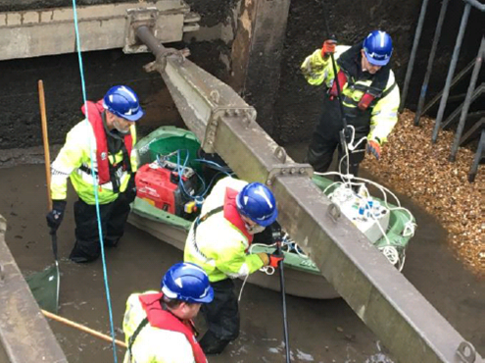
For further information please contact Stuart Manwaring. stuart.manwaring@environment-agency.gov.uk

River Bourne
The Environment Agency, Surrey Wildlife Trust and St Georges College are delivering a habitat improvement project on the River Bourne at Weybridge. So far the project has seen the introduction of twenty tonnes of gravel in strategic locations to provide spawning habitat for the many species of fish which frequent the river. In addition to the gravel introduction several berms have been created using chestnut stakes and brash. The berms are designed to pinch the river and increase velocity to cleanse the river bed and wash move loose sediment which improves habitat for both fish and invertebrates. This project will also see the reconnection of a backwater to the river providing a location for fish to move out of the fast flows during high water conditions.
For further information on this project please contact Adrian Bicknell. adrian.bicknell@environment-agency.gov.uk

Wadley Stream
The Wadley Stream is a small tributary of the Thames. The original channel has been diverted and straightened. Scrub has been allowed to shade the channel and as a result the banks are bare of vegetation and eroding. In February Laurence and Jim joined staff from the Berks Bucks and Oxfordshire Wildlife Trust (BBOWT). We cleared several sections of hawthorn allowing light to get to the banks and to the stream. In addition we put in deflectors to promote scour and provide shelter for fish during high flows.
For further information please contact Jim Seymour. james.seymour@environment-agency.gov.uk

River Whitewater
A recent advisory visit by fisheries and biodiversity officers to the River Whitewater will see the reconnection of an old oxbow lake to the river. This will provide important backwater habitat for both fish and wildlife. This section already provides some great habitat with lots of woody debris present within the channel and some great pool and riffle sections. The owner of this site is very keen to retain this important habitat and also recharge some existing gravel riffles to improve spawning habitat for both the wild trout and coarse fish which are present in this section of river.
For further information on this project please contact Adrian Bicknell. adrian.bicknell@environment-agency.gov.uk

Habitat Improvements on the River Thame at Shabbington
The River Thame splits into 2 channels at Shabbington. Tring Anglers own the land and the fishing between the 2 channels. The club use this fishery to organise fishing days for juniors, along with other events. They also encourage local access.
The site was becoming difficult to access due to vegetation growth, particularly nettles, and excessive willow growth. In addition the back channel had become choked with aquatic vegetation, making fishing difficult. Fish numbers had also declined, as shown by angler catches and survey results.
The club wanted to improve the access for fishing and to improve the habitat. The habitat improvements fitted in with other work on the Thame trying to make the river more resilient to water quality problems, etc.
The Tring Anglers planned a major enhancement of the site with advice from Andy Killingbeck (Fisheries Technical Specialist). The club members did a lot of bankside vegetation, clearance of nettles and old barbed wire fencing. The club also organised a contractor to pollard the willows. The Environment Agency organised FIP (Fisheries Improvement Programme) money to pay for the pollarding. The Fisheries team helped clear various debris jams in the back channel and installed D shaped berms and some large woody debris (LWD) to narrow the channel. Fisheries Officers also helped trim or remove willow branches that were inaccessible to the tree contractor.
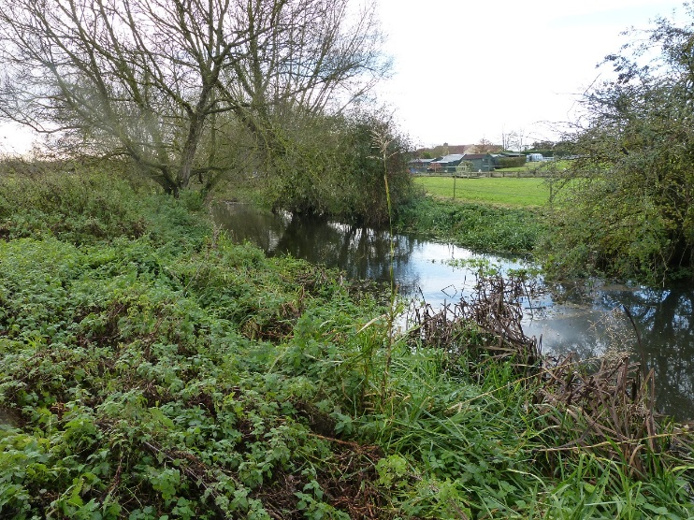
For further information on this project please contact Andy Killingbeck. andy.killingbeck@environment-agency.gov.uk

Anglers caught illegally fishing to pay £1700
On 12 February 2018, at Guildford Magistrates court, Lee Grant of 19 Eton Road, Southsea, and James Black of 4 Heathyfields Road, Farnham were each fined £660 for fishing without a fishing licence, with costs of £127 and a victim surcharge of £66 imposed after a prosecution by the Environment Agency. The total penalty was £853 each.
Magistrates heard that on 23 September 2017, an Environment Agency enforcement officer found Lee and James fishing at Badshot Lea Ponds, Badshot Lea. A valid fishing licence is required to fish all waters in England. Neither were able to produce a valid fishing licence and were reported for that offence.
James and Lee were each convicted in their absence.
During 2015-16 the Environment Agency checked more than 62,000 fishing licences and prosecuted more than 1,900 anglers for rod and line offences resulting in fines and costs in excess of £500,000.
Anyone witnessing illegal fishing incidents in progress can report it directly to the Environment Agency hotline, 0800 80 70 60. Information on illegal fishing and environmental crime can also be reported anonymously to Crime stoppers on 0800 555 111.

Stocking for Bracknell’s River Cut
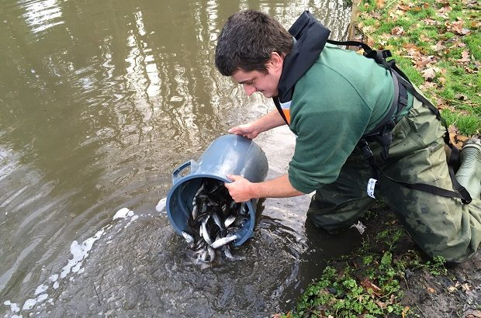
We have reported on Bracknell Town Council and Stuart Keable's habitat improvement work on the Bracknell Cut in the previous Newsletter. Being sited on the edge of an urban centre brings inevitable challenges and this year the river has unfortunately been polluted on several occasions. But rather than being deterred, the partnership has taken this as a cue to engage the local public and business communities in an awareness campaign that is steadily gathering strength. Thames Water, which oversees the drainage network below Bracknell, has joined forces with the Environment Agency to investigate and send out a strong message to deter dumping of oil and chemicals into roadside drains. As the threat of pollution now looks to be receding, Stuart decided it was safe to boost the river’s native stock of fish from our national fish-rearing facility in Calverton. So on Thursday 14 December 2017, we introduced around 2,000 juvenile chub, roach and dace to help ensure a brighter future for this remarkable little river.
For more information please contact Stuart Keable stuart.keable@environment-agency.gov.uk

Jubilee River
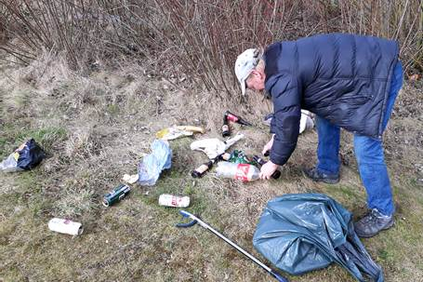
TVAA bailiff Adrian Bentley gets stuck into some rubbish on the Jubilee River.
‘Some of the Environment Agency’s most vital work revolves around flood alleviation. However, one major asset controlled by the EA in Thames area now fulfils dual roles as both a flood relief channel, protecting thousands of homes, and as an increasingly productive fishery. A large stretch of the 11km long Jubilee River is managed as a fishery on behalf of the EA by Thames Valley Angling Association. The TVAA offers excellent fishing on the channel to all members of its affiliated angling clubs with huge specimen bream into double figures, carp, pike, roach and perch. Being publicly accessible along most of its route though, litter can be an issue. So this spring, as the river fishing season draws to a close members of the TVAA descended on the channel at Taplow to conduct a litter pick. Several bags of rubbish were removed and they even sold a few day tickets to passing anglers in the process. If you are interested in fishing the Jubilee River visit the TVAA website in the first instance at http://thamesvalleyaa.webs.com/member-clubs .

Environment Agency unveils new fishing licence images
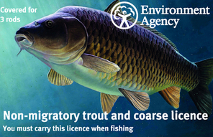
To the delight of the country’s anglers, the Environment Agency has revealed today that Clarissa the Carp (Cyprinus carpio) - for 28 years a UK record weighing Carp - will be represented on the front of the Environment Agency’s fishing coarse & trout licence. Clarissa was chosen to mark the centenary birth of renowned angler Richard “Dick” Walker, who, on 13 September 1952, landed a carp of 44lb which beat the previous record by nearly 13lb. The fish, caught from Redmire Pool, was taken to London Zoo aquarium. In the 1950’s fish were routinely killed to establish their weight and often put in a glass cases. Walker hated the idea of killing such a magnificent creature and persuaded the aquarium’s curator to take her on. She was there named Clarissa the Carp – although Dick Walker himself called her Ravioli.
The choice for this year’s image will be welcomed by coarse fish anglers who have campaigned for Walker’s contribution to angling to be acknowledged. His record catch stood until 1980 when it was beaten by a fish of 51½ lb from the same water. As the inventor of ‘Arlesey bomb’ angling weight, the first electronic bite alarms and because of his involvement in the development of carbon fibre fishing rods, he is considered a pioneer.
The other fishing licence images unveiled today are the gudgeon (Gobio gobio) and the salmon (Salmo salar).
Sales of fishing licences for the 2016/17 season raised £21 million. The money was used to restock rivers with 6,335,000 fish, encourage over 35,000 people to try angling for the first time and bring 2,330 successful prosecutions against crimes like poaching.
The fishing licence lasts for 12 months from the day it is bought, rather than expiring at the end of March each year. People are required to buy a fishing licence in order to fish legally in England, Wales and along the Border Esk in Scotland.

Chalgrove Brook
Fisheries officers introduced 1.6 tonnes of gravel into the Chalgrove brook near Watlington. The gravel introduction is part of an ongoing project to improve habitat for brown trout on the Chalgrove Brook. Watlington Environment Group have undertaken work parties to reduce shading to encourage in stream and marginal weeds to grow. The group has also created stone berms to narrow the channel and provide flow variation in an otherwise straight channel. The project is continuing with more improvements planned for the coming year.
For more information please contact laurence.hook@environment-agency.gov.uk

Contact Us
If you would like any further information about any articles in this newsletter or have any other queries please contact Jim Seymour. james.seymour@environment-agency.gov.uk
Tel: 02030259657
Follow our Fisheries Enforcement Team on Twitter- Twitter@NickRobinsonEA
Follow the Environment Agency on Twitter – Twitter@EnvAgency or on Facebook at www.facebook.com/environmentagency

