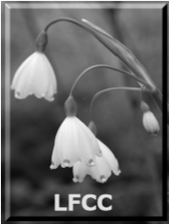
Loddon Fisheries and Conservation Consultative Membership Application/Renewal Form for 2023
I/We wish to apply or renew our Membership of the Loddon Fisheries and
Conservation Consultative
Existing Membership Number
LFCC
Please indicate as appropriate
Club | Council | Wildlife Trust | £25
Personal | Landowner |  | £15

Name ______________________________

Email Address (This will be used for most communications)
____________________________________________________________

Address __________________________ __________________________
__________________________

Post Code ___________________________

Telephone _________________________

Name of Club/Organisation _______________________________

Number of Members _______________

EA Region Thames South East

Date ________________ Signature ________________
NOTE: by completing this form you are consenting to having your details recorded on a computer database. The Loddon Consultative guarantees that these details shall not be divulged to a third party for any reason. Your details will not be used for any purpose other that as set down in the constitution of the Loddon Consultative.

PLEASE NOTE that membership renewals become due on the 1St of January each Year.

If you wish to pay by Bank Transfer, which is preferable, our sort code is 20-71-03 a/c 30805300 please quote your LFCC membership no in the reference section and email ashton.trevor100@gmail.com with this form, to inform that you have paid (amount and date).
Please make cheques payable to LFCC.
Please complete this form and post it together with the appropriate subscription to Trevor Ashton (Treasurer LFCC), Peacehaven, Church Path, Hook, Hants. RG27 9LZ

